Start of Choir Details

Hello choir students and parents! I’m so glad that you have chosen to participate in the the WFGMS Choir Department! I know that it is going to be a great year! Please take a moment to look over all of the following important details for the upcoming choir year!
Attendance/Rehearsal
The success of our ensemble depends upon the attendance and participation of all students. It is important to arrive on time and be ready to sing as soon as you arrive. If you want to make sure that you are on time, feel free to come 5 or 10 minutes early for rehearsals and performances. Parents: if your child is unable to attend a rehearsal or performance, please send me an email or give me a call to let me know as soon as possible as their grade depends on it! Attendance will be taken at each rehearsal at the beginning of class. I understand that instances may arise in which a student is unable to attend. Please try to limit these absences throughout the year.

***Students are encouraged to bring a WATER bottle to class! They can store them in the Choir Hall! ☺***

Performance Attire
At casual performances throughout the year, students will be asked to wear a nice pair of blue jeans (no holes please), a nice pair of tennis shoes (no sandals), and their Choir Shirt. Please fill out the attached t-shirt order form and return it with your child by August 30th. (Most like to buy more than one just in case a student grows out of their shirt or they lose it!).

Parent Booster Club Details
Our Iowa Park Choir Booster Club is a parent sponsored group that helps assist the needs of the choir programs. The Booster Club meets only once a month (with the exception of our officers) to discuss fundraisers, needs, and volunteer work. If you are interested, we could always use more parents! Please contact any of the officers below for more information:

President- Louis Booth: 940-224-8627

Secretary- Lisa Martin: 940-642-0693

Treasurer- Amber Morrow: 940-782-7826

All choir performances are major tests grades. If a student misses a performance they will have an alternate assignment to complete in it’s place. We will have various choir events throughout the year that are optional but highly suggested for attendance. Attached is a copy of the choir calendar for the year!

I am looking for a few volunteers who are willing to help “chaperone” the students during a concert/event, or set up/decorate for concerts. If you would be willing to help in some way, please let me know on the attached shirt order form! As always, please don’t hesitate to contact me if you have any questions or concerns! I am excited for the upcoming choir year, and I look forward to a successful year of learning and growing with our students! ☺

Thank you,
Hannah Espinoza Cell: 940-632-8540
Email: hespinoza@ipcisd.net
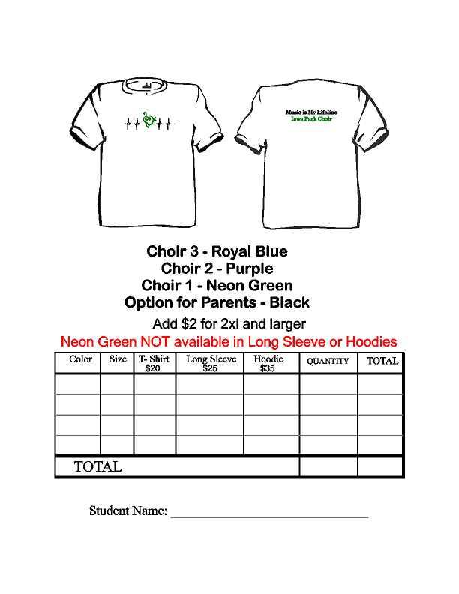
I would be willing to help out/chaperone at one (or more) of the

WFMG Choir events this year! (Please fill in below and circle one if willing to help).

Parent Name: ______________________ During School After School Either

